* 1. Design a flowchart to take an integer consisting of 4 digits as input and print the last 2 digits of that number.
* 2. Design a flowchart to take an integer consisting of 4 digits as input and print the first 2 digits of that number.
* 3. Design a flowchart to take three integers a, n, d as input where a is the first term of an arithmetic sequence, n is the number of terms and d is the common difference between the terms in the sequence and print the n-th term of the arithmetic sequence.
* 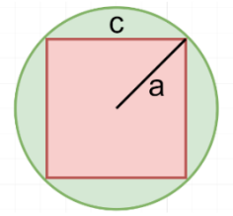4. Design a flowchart to take two numbers a and c as input (look at the image below) and print the area of the portion colored in green. In the following image, a is the radius of the circle, and c is the length of the sides of the square.

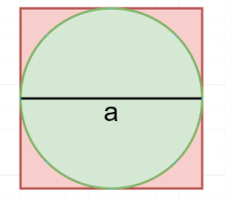

* 5. Design a flowchart to take a number as input (look at the image below), and print the area of the portion colored in red. In the following image, a is the diameter of the circle.